Dream Weaver - Picnic
Games
E-Project
Design Guide
Supervisor: Sir Fasial
Group Member
Enrolment ID | Name
Student1727254 | Sahir Alam
Student1727251 | Ali Bilal
Student1724222 | Muhammad Anas

Curriculum:7144
Batch Code:2507E8
Semester: 1st semester(ADSE)



Explore with "Dream Weaver Picnic"

"Dream Weaver Picnic Games is an event management and entertainment website designed to provide exciting picnic games and outdoor activities for schools, colleges, companies, families, and friends. The website showcases a wide variety of fun games, team-building activities, and event packages with clear descriptions, images, pricing, and booking details. It also includes features such as online booking, downloadable event brochures, responsive design, and easy navigation to help users plan memorable picnic experiences. Overall, Dream Weaver Picnic Games aims to deliver enjoyable, engaging, and well-organized outdoor events for people of all ages."

Objectives of the Website

• Provide picnic and game information.
• Showcase kids and adults activities.
• Display gallery and play zones.
• Allow users to contact the team.
• Provide an engaging user experience.
Problem statement

In today’s busy and active world, quality time with family, friends and relatives is often overlooked, but picnics can be helpful in making up for some of this lost time.
Spending time together benefits children by providing security, love, and a sense of belonging. Taking time to talk with your children is a great way to connect with them and learn from each other. Regular communication can also give family members chances to plan other fun and engaging activities.
Fun games and little competitions are great ways to keep children occupied while engaging with the family.
Hence it is thought of developing a website which will provide variety of indoor/outdoor picnic games that enjoyed with all.

Requirement Specification: Dream Weaver Picnic Games
The website is to be created based on the following requirements:
1) The Home Page should include a professional logo, attractive header/banner, and featured picnic game images.
2) The site must contain navigation links to Kids Games, Adult Games, Indoor Games, Outdoor Games, Gallery, About Us, Contact Us, and Queries.
3) Games should be categorized into Kids Picnic Games, Adults Picnic Games, Team Building Games, and Fun Activities.
4) Each game should include a description, rules, number of players, and required equipment.
5) A Gallery section should display images of picnic events and games.
6) A Feedback form should allow visitors to submit reviews.
7) Site Map, Gallery, About Us, Queries, and Contact Us links must be included.
8) The complete project description should be downloadable as PDF or DOC.
9) An advertisement section highlighting picnic packages and facilities should be included .

Hardware/ Software Requirements

Hardware
- A minimum computer system that will help you access all the tools in the courses is a Pentium 166 or better
- 64 Megabytes of RAM or better

Software [Either or Combination as per Course/Sem]
- Notepad/HTML editor/CoffeeCup
- Angular / Angular JS / React / BootStrap
- Dreamweaver / Figma
- MS IE / Chrome / FireFox / Netscape /MS Edge

.
1. home
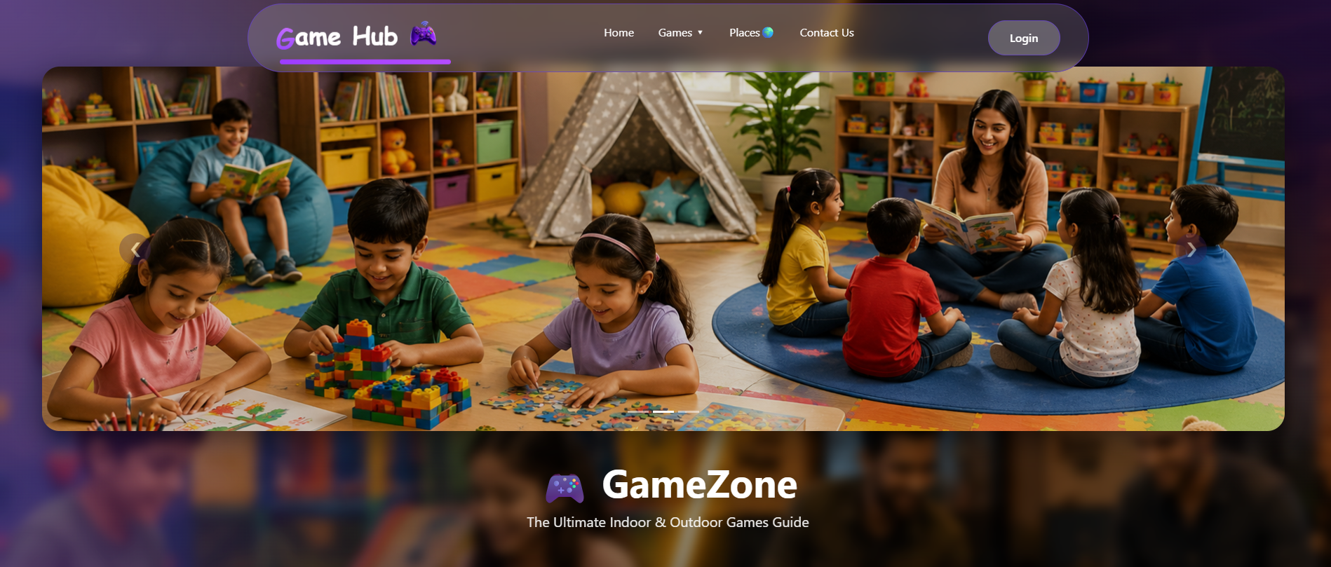

2.Adults&Kids
Zone

Adults Zone: offers a wide variety of engaging indoor and outdoor games designed to provide entertainment, relaxation, and healthy competition for adults. Indoor activities such as Chess, Poker & Rummy, Billiards, sports, and Board Games encourage strategic thinking, teamwork, and social interaction. For those who enjoy physical activities, the Outdoor Games section includes Cricket, Football, Badminton, Running, and Cycling, promoting fitness, adventure, and an active lifestyle. Whether you're looking for a fun challenge or a way to stay healthy, the Adults Zone provides exciting game options for every interest and skill level.
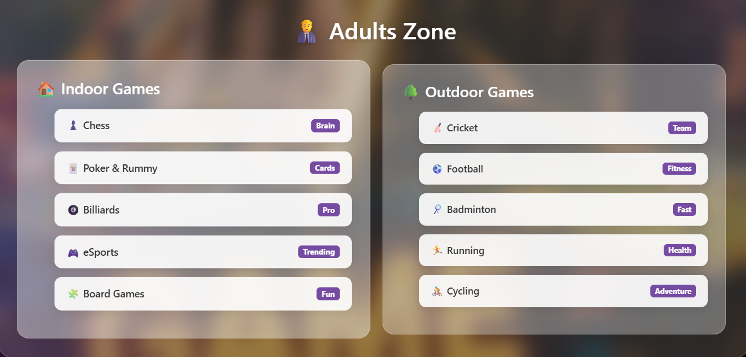

Kids Zone : is specially designed to provide children with a fun, safe, and engaging environment where they can learn, play, and grow. The Indoor Games section features creative and educational activities such as Drawing & Craft, Lego Building, Snake & Ladder, Role Play, and Jigsaw Puzzles that help improve imagination, problem-solving, and cognitive skills. The Outdoor Games section includes exciting activities like Hide and Seek, Tag, Hopscotch, Kite Flying, and Park & Swings, encouraging physical fitness, teamwork, confidence, and social interaction. Together, these games create memorable experiences while supporting children's creativity, learning, and overall development.
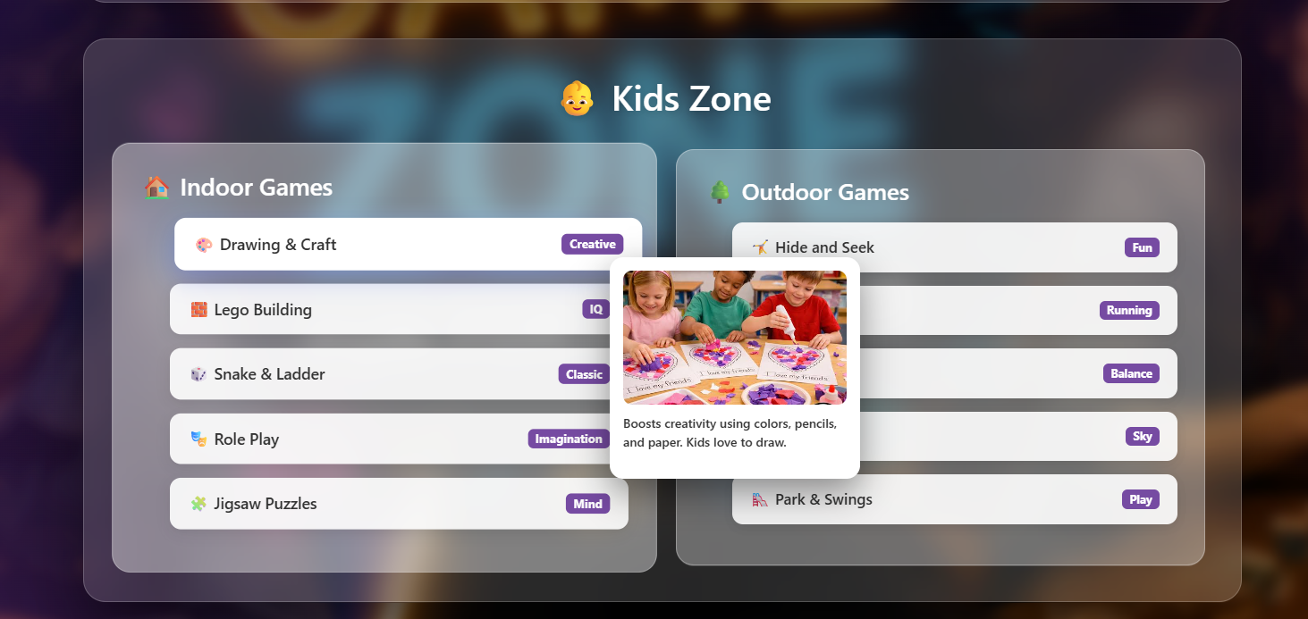

Kids & Adults Picnic and palying Places

Kids: Game Hub – Places & Play Zones offers exciting and well-designed recreational spaces where children can enjoy learning, creativity, and active play in a safe environment. The Kids Play Zones feature areas such as the Soft Play & Toy Area, where young children can explore building blocks, puzzles, and interactive activities, along with the Creative & Arcade Corner, which combines educational games and modern arcade experiences to enhance creativity and problem-solving skills. In addition, outdoor attractions like kite flying, cycling, and playground activities encourage physical fitness, teamwork, and social interaction. Every play zone is designed with safety, fun, and child development in mind, ensuring an enjoyable and memorable experience for kids of all ages.
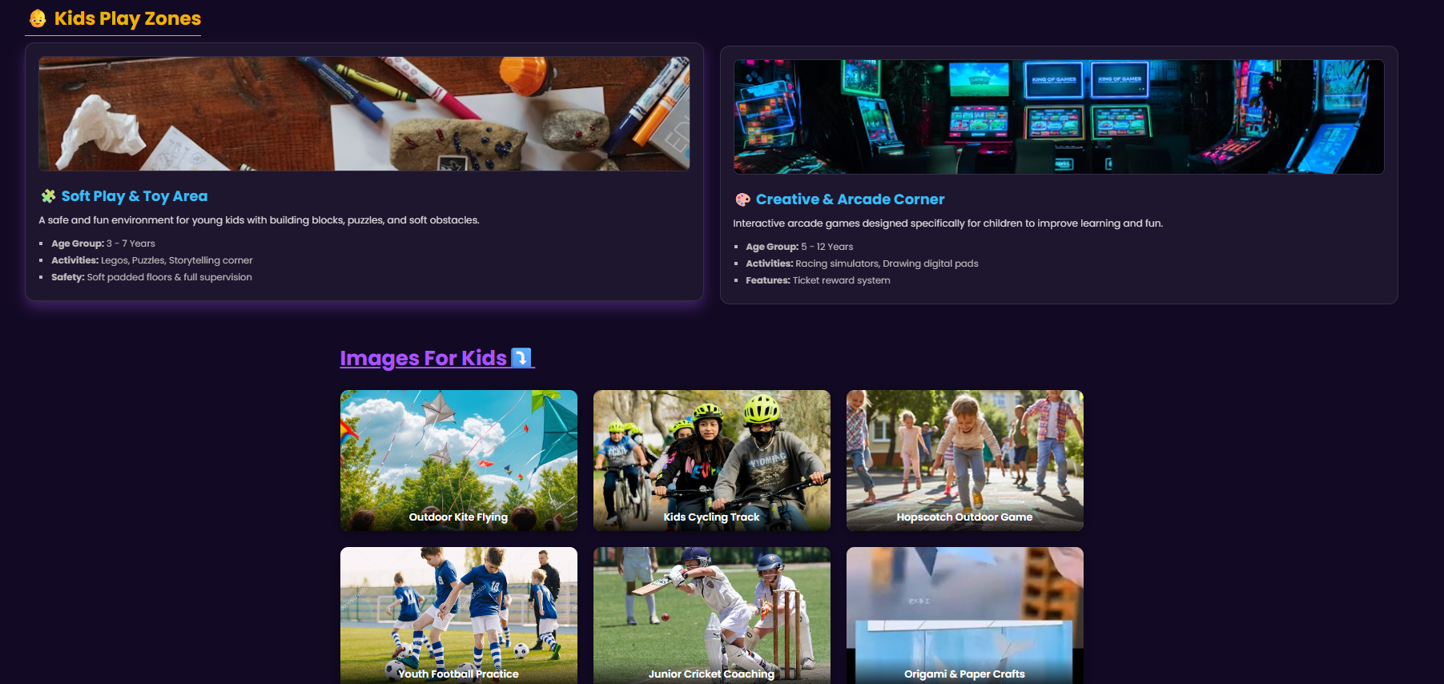

Adults: Adults Gaming Lounge is designed to provide a premium entertainment experience where adults can socialize, and enjoy a wide variety of recreational activities.
The lounge features Indoor Sports & Recreation such as Pool, Snooker, Table Tennis, and Chess, offering the perfect setting for friendly matches and competitive tournaments. For enthusiasts, the E-Sports & Console Arena includes high-performance gaming PCs, PlayStation 5, Xbox Series X, VR and popular multiplayer titles, delivering an immersive and exciting gaming experience. Whether you're looking to unwind classic indoor games or compete in the latest destination.



Contact Us

Contact Us is your direct connection to the Game Hub team. Whether you have questions about our gaming zones, want book an event, share feedback, or need assistance with our services, we're here to help. Simply fill out the contact form details and message, and our support team will respond as quickly as possible. We value your suggestions and strive to provide a friendly, reliable, and enjoyable experience for every visitor. Your feedback helps us improve and create even better gaming experiences for kids, adults, and families .

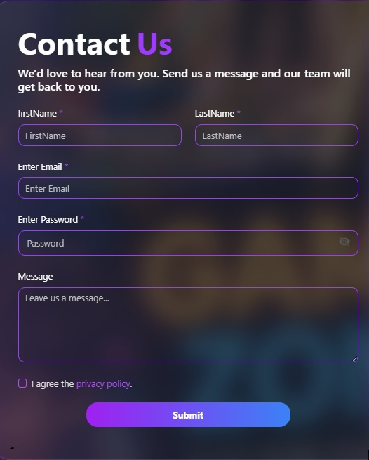

Site Map
Location/FindUs:
Find Us at Game Hub, where fun, entertainment, and unforgettable gaming experiences come together. Our convenient location makes it easy for families, friends, and gaming enthusiasts to visit and enjoy our wide range of indoor and outdoor activities. Whether you're planning a family outing, a birthday celebration, a school trip, or a friendly gaming session, our venue is easily accessible and offers a safe, welcoming environment for visitors of all ages. Use the map below to locate us and start your next gaming adventure with Game Hub.

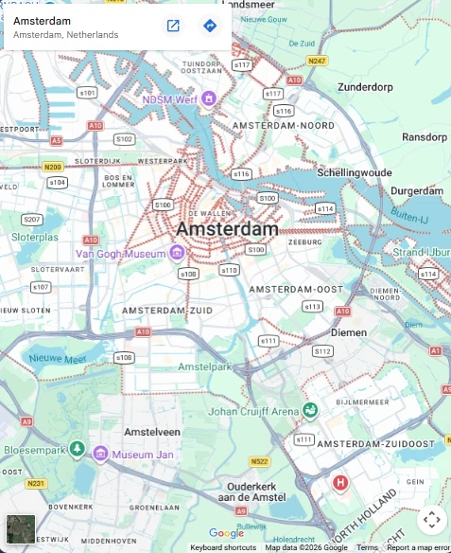
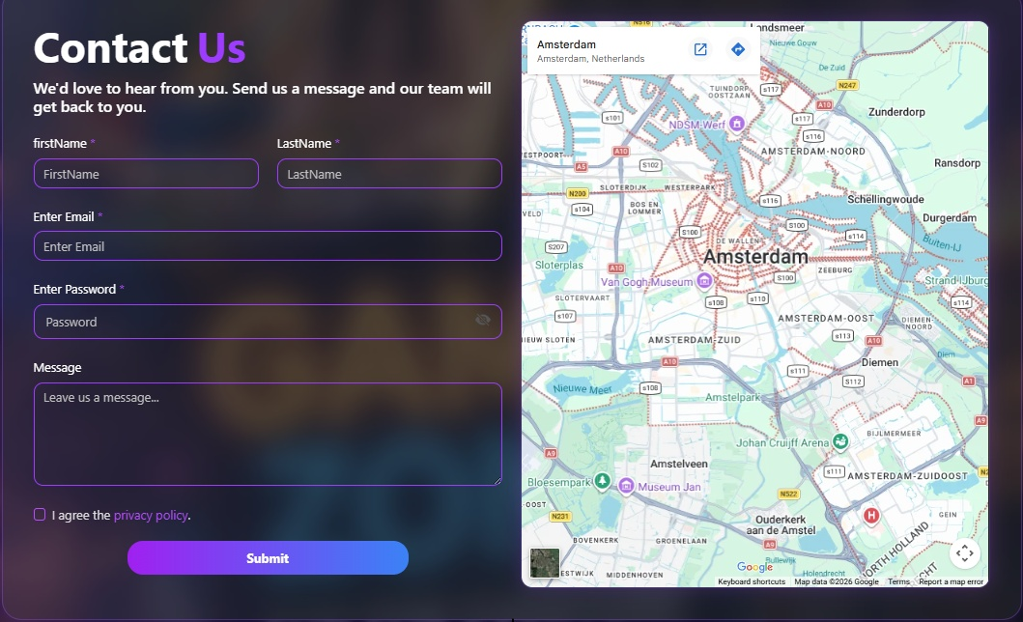

Footer
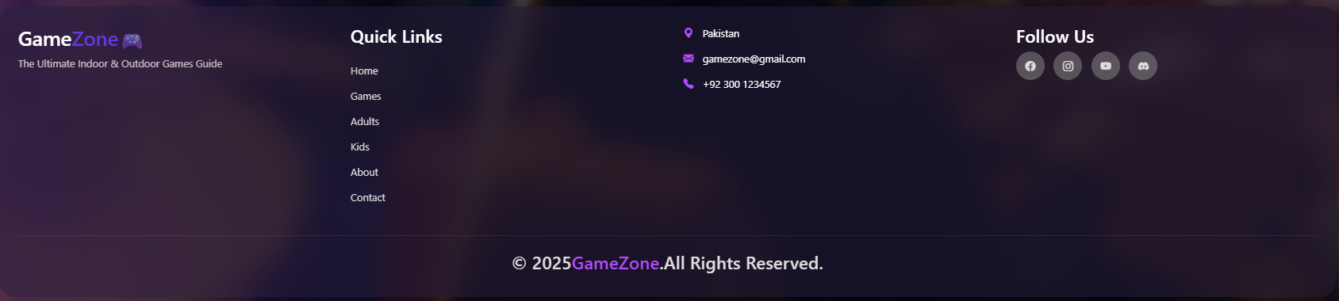

Wireframe Description
Footer | Rounded dark footer section
Logo | GameZone / Dream Weaver Picnic Games
Quick Links | Home, Games, Adults, Kids, About, Contact
Contact | Pakistan, Email, Phone
Social Icons | Facebook, Instagram, YouTube, Discord
Copyright | ©2025 Dream Weaver Picnic Games

